Summary Document

This assignment item 4 submission contains Master Test Plan, Development directory containing all source code, test code, library folder and a Reflective report.

**Here is the screen shot showing the directory structure:**

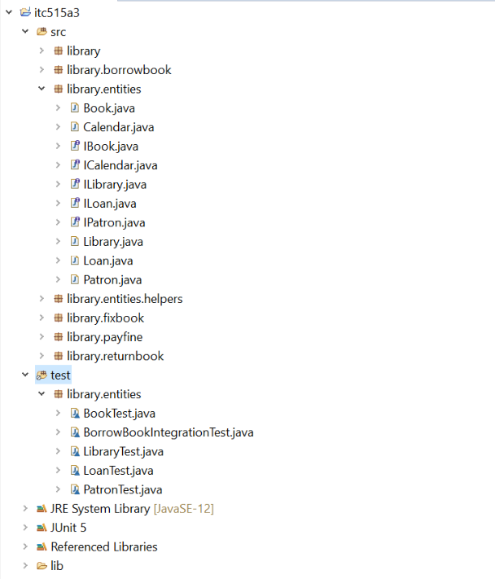

Fig 1: Directory Structure

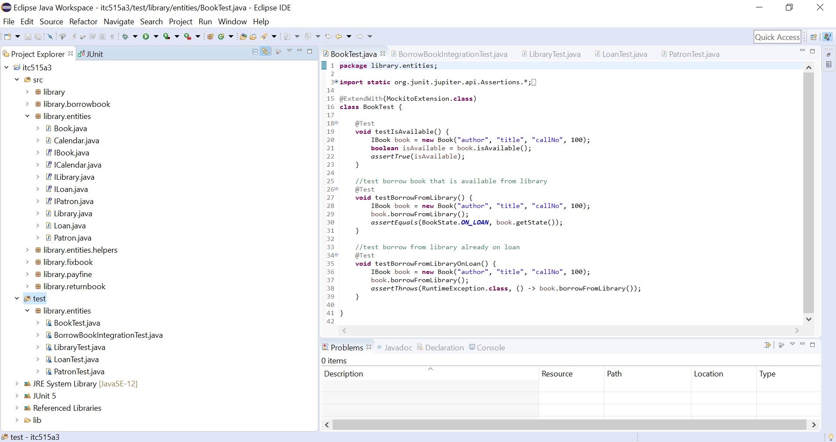

Fig: Directory Structure in the environment

**Here is screenshot of the test code with test results:**

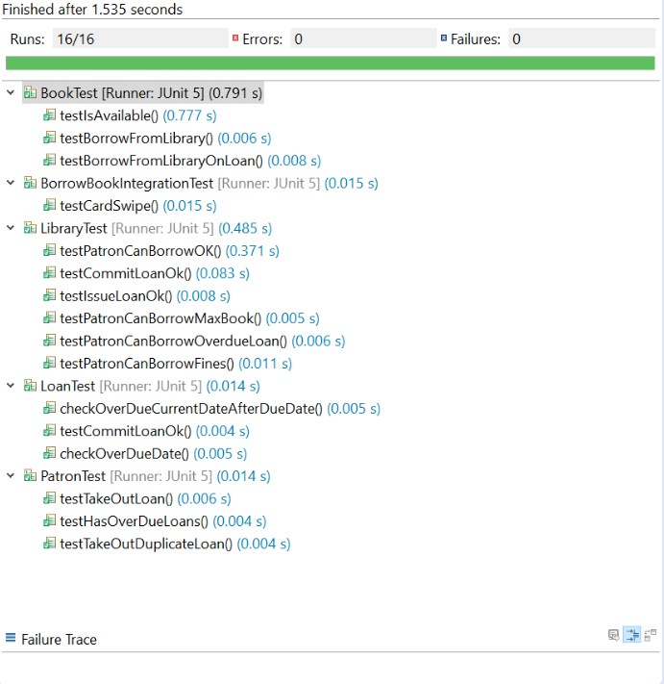

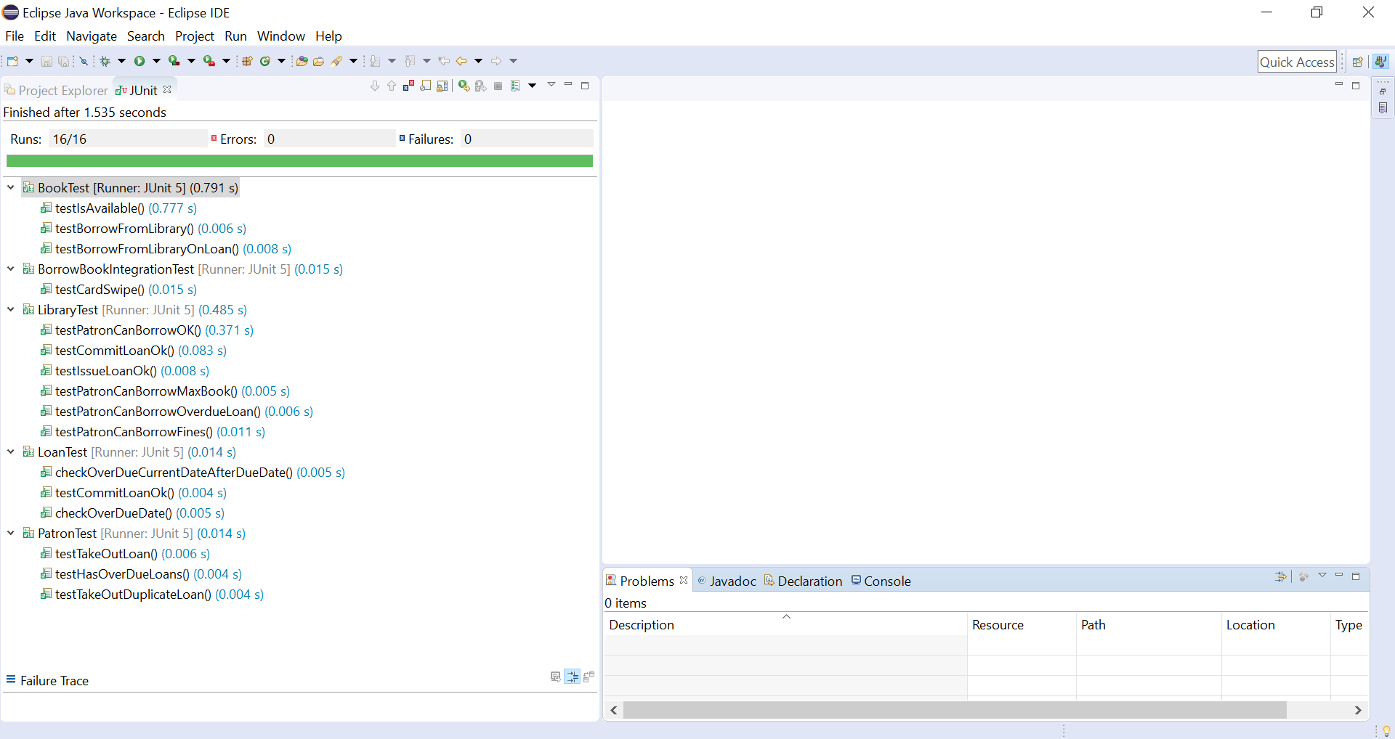

Fig 3: Test Code with Test Results